

**The PlayStation Store**

**Overview**

The PlayStation Store is an online digital storefront and distribution platform operated by **Sony Interactive Entertainment (SIE)**. It serves as the primary digital marketplace for purchasing and downloading video games, add-ons, DLC (Downloadable Content), movies, TV shows, and other digital content for Sony's PlayStation gaming consoles, including the PlayStation 5 (PS5), PlayStation 4 (PS4), PlayStation 3 (PS3), and other gaming consoles.

**The PlayStation store: Revolutionizing Convenience and Accessibility:**

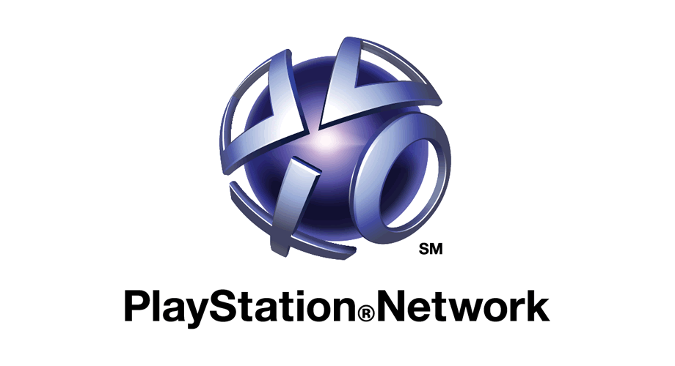

The PlayStation Store was launched by Sony Interactive Entertainment (SIE) and was introduced alongside the PlayStation 3 (PS3) console in November 2006. It has since evolved and expanded to support multiple PlayStation platforms, including the PS4, PS5, and handheld devices.

**Why PlayStation Store?**

It revolutionizes convenience and accessibility for users. Gamers can effortlessly purchase and download their favourite digital content, whether it's games, movies, or TV shows, from the comfort of their own homes. This eliminates the need to visit physical stores or wait for physical copies to be shipped, saving time and effort while providing instant access to entertainment making it a one-stop shop for PlayStation users. The convenience factor has become especially crucial in the fast-paced digital age, making the PlayStation Store a solution to this modern problem

Additionally, the PlayStation Store contributes to environmental sustainability by reducing the environmental impact associated with physical media. By promoting digital downloads, it eliminates the need for manufacturing and shipping physical discs, reducing carbon emissions and waste. This aligns with the growing emphasis on eco-conscious practices and sustainability in the entertainment industry. As consumers increasingly look for environmentally responsible options, the PlayStation Store also introduced digital version that helps mitigate the environmental challenges posed by physical media distribution, making it a responsible choice for eco-minded gamers.

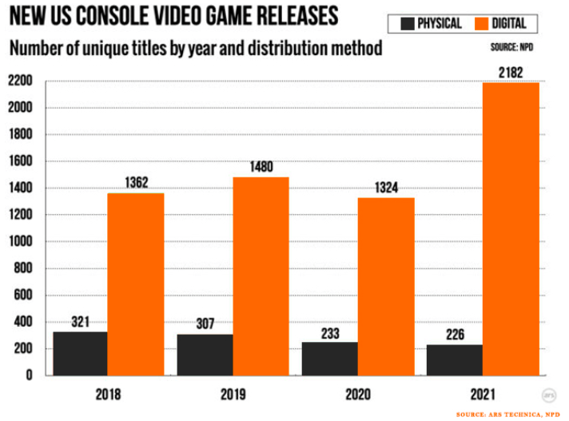

**Real-world problems solved by PlayStation Store:**

1. **How can digital marketplaces like the PlayStation Store improve the convenience of accessing entertainment and gaming content for users?**

The PlayStation Store addresses the inconvenience of physical game purchases. It is available 24/7, allowing users to browse, purchase, and download games and content at any time, whether it's day or night. This accessibility caters to users with varying schedules and time zones. Users can buy and download games from the comfort of their homes, eliminating the need to visit a physical store. Digital downloads eliminate the need to store physical game discs, reducing clutter and the risk of discs getting damaged or lost. This is especially beneficial for users with limited storage space.

1. 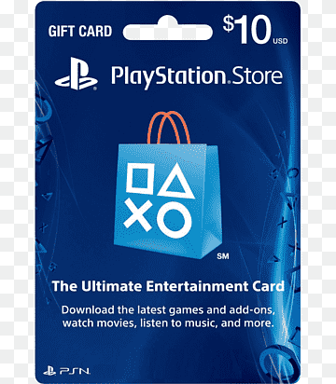**What strategies can be implemented to ensure that digital content distribution platforms like the PlayStation Store can effectively reach and serve a global audience?**

It solves the challenge of global distribution by providing access to games and content to users around the world, transcending geographical boundaries. The Store Accepts a wide range of payment methods, including credit/debit cards, digital wallets, and region-specific payment options. Ensure that users from different countries can make purchases conveniently and securely.

1. **In what ways can digital distribution platforms like the PlayStation Store contribute to reducing the environmental impact of the gaming industry compared to physical media?**

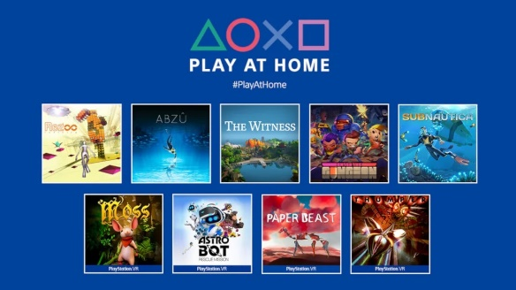By promoting digital downloads over physical media, the PlayStation Store reduces the environmental impact of game distribution. It minimizes the need for manufacturing, packaging, and shipping physical game discs and hard case contributing to environmental sustainability. Digital games have an extended product lifecycle since they don't degrade over time or suffer from wear and tear like physical discs. Gamers can continue to access their digital libraries for years without worrying about deterioration. Also, downloading games and content directly from digital platforms consumes less energy compared to producing physical media and transporting it. This contributes to lower energy consumption and, subsequently, reduced environmental impact. From the consumer end, they don’t have to travel kilometres/miles to the gaming stores which will also help to reduce carbon emissions.

1. **What features and functionalities within digital gaming marketplaces, such as the PlayStation Store, contribute to building and sustaining vibrant gaming communities and social interactions among players?**

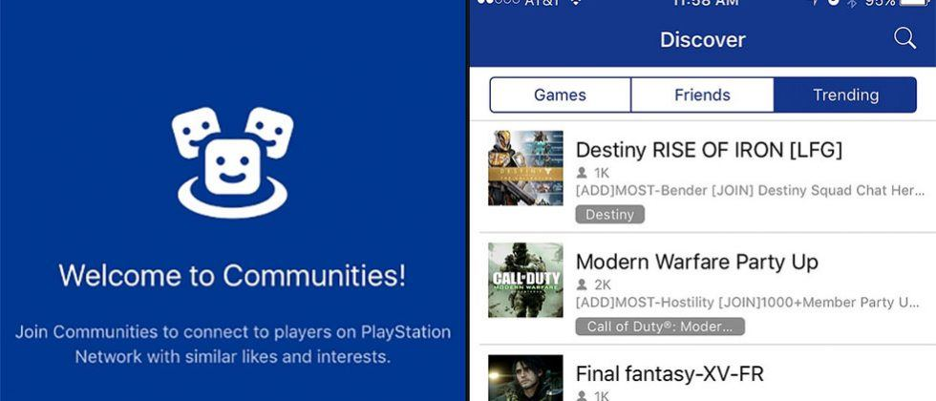

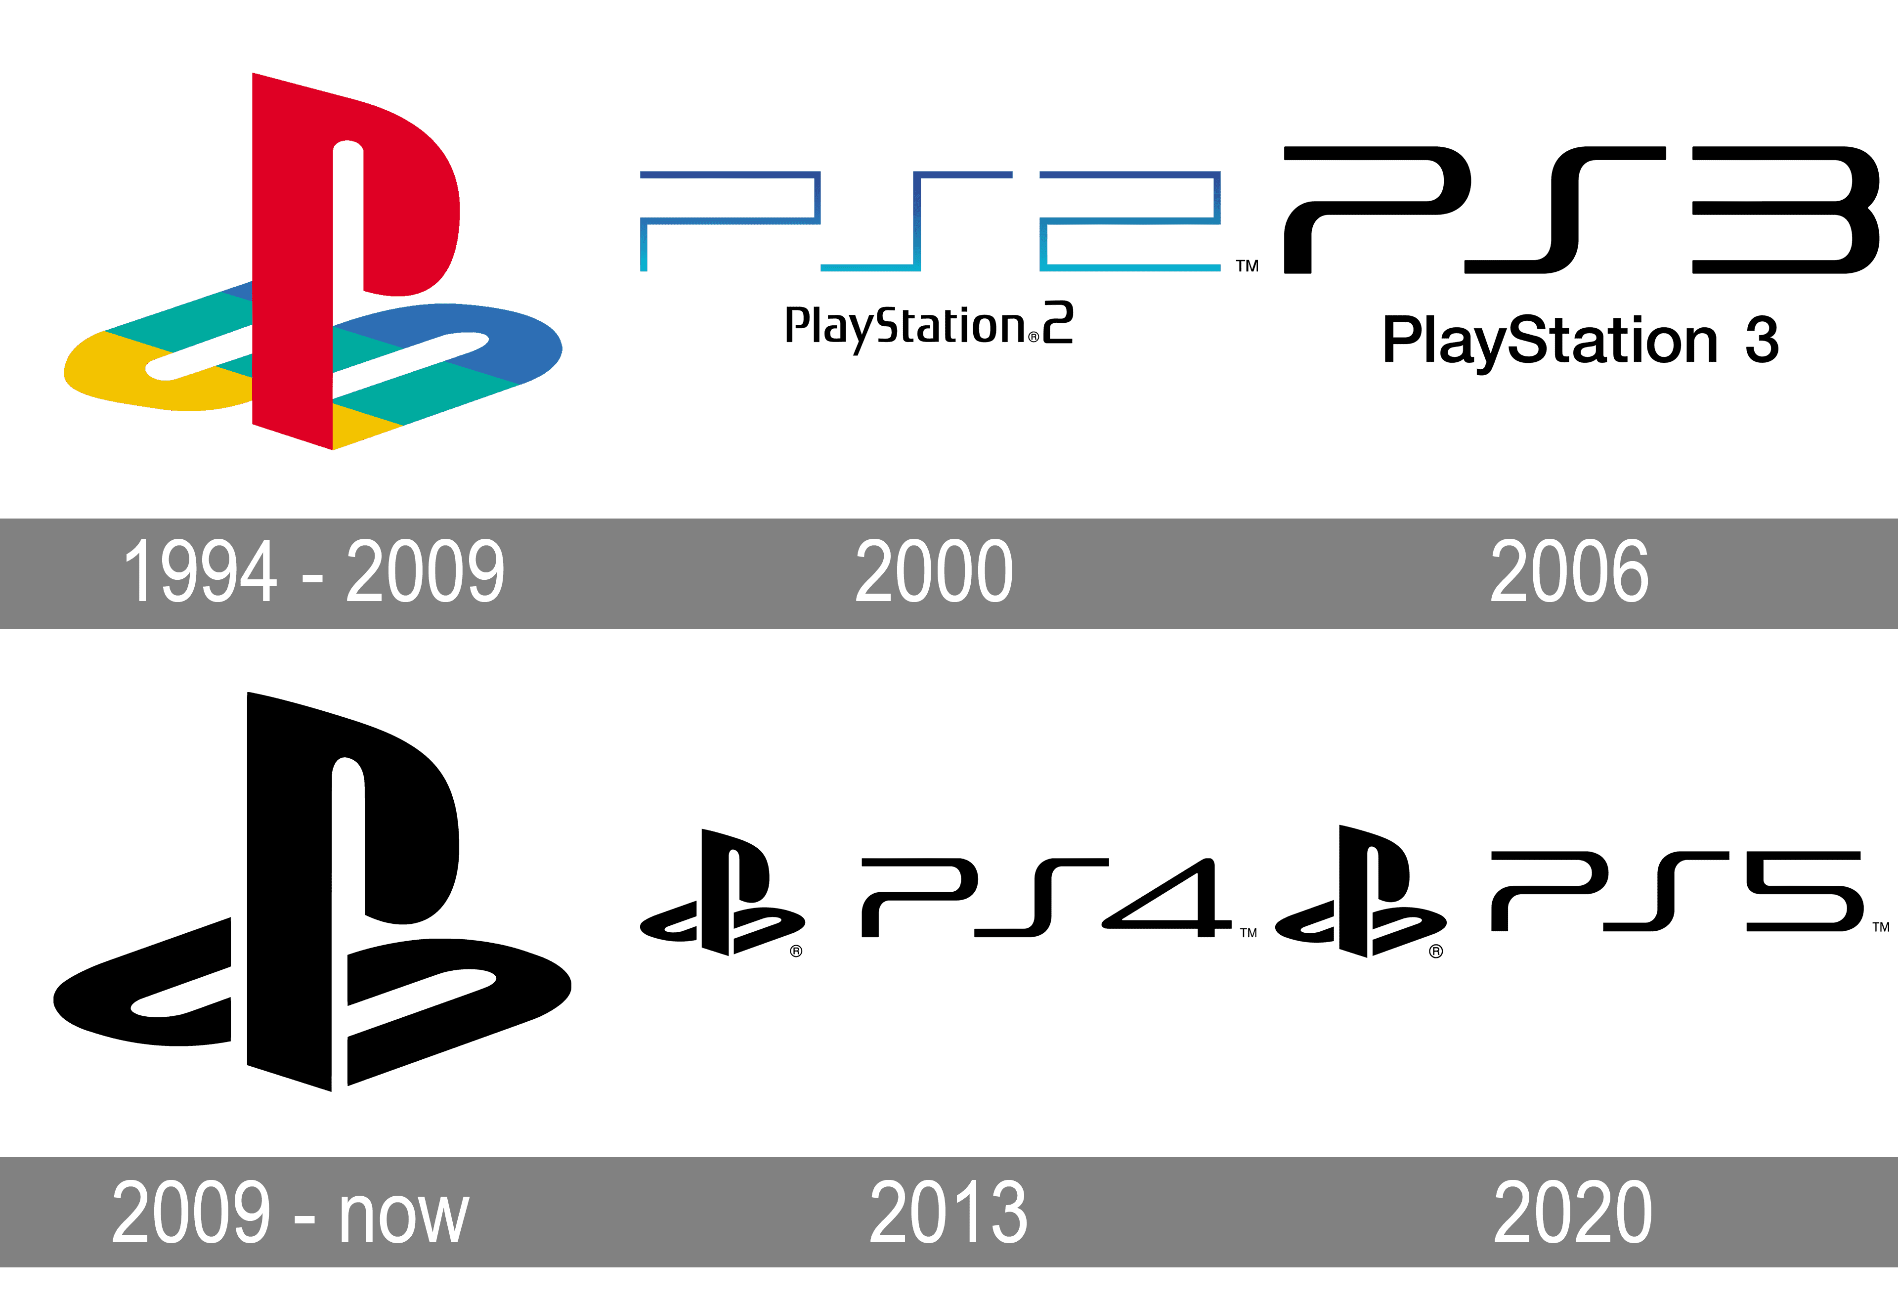The store fosters community building by facilitating online multiplayer gaming, social features, and communication among players. This innovative approach connects gamers worldwide, fostering a sense of community and shared experiences. This allows players to team up or compete against others from around the world, creating opportunities for social interactions and cooperative gameplay. Platforms like the PlayStation Store use algorithms to provide personalized game recommendations based on a player's gaming history and preferences, helping players discover new titles and engage with the gaming community. The ability to rate and review games and content fosters community-driven feedback. Players can read reviews, share their opinions, and engage in discussions about their favourite games.

In **Conclusion**, the PlayStation Store has transformed the gaming and entertainment landscape by solving a myriad of real-world problems. Its innovative digital distribution platform has revolutionized how user’s access and enjoy content, offering convenience and accessibility like never before. By transcending geographical barriers, it has connected gamers globally and built vibrant gaming communities. In summary, the PlayStation Store's solutions to real-world challenges have not only reshaped the gaming industry but have also set a high standard for digital distribution platforms, offering a comprehensive, accessible, and environmentally responsible approach to gaming and entertainment.

**Top features of PlayStation Store**

The PlayStation Store is a digital storefront for Sony's PlayStation gaming platform, offering a wide range of features and services to enhance the gaming experience for PlayStation users. Here are some of the top features of the PlayStation Store:

1. **Exclusive Titles:** PlayStation often releases exclusive games available only on their platform. These exclusives are highly anticipated by gamers and are a significant feature of the PlayStation Store.
2. **Discounts and Sales:** The store regularly offers discounts and sales, including seasonal promotions, holiday sales, and flash deals, allowing users to purchase games at reduced prices.
3. **PlayStation Plus:** PlayStation Plus is a subscription service that offers free monthly games, exclusive discounts, early access to demos, and access to online multiplayer gaming.
4. **Cross-Platform Play:** Some games support cross-platform play, allowing gamers on different PlayStation consoles to play together, as well as with players on other platforms.
5. **Game Ratings and Reviews:** Users can read and leave reviews and ratings for games, helping others make informed purchasing decisions.
6. **Wish List:** Users can create a wish list of games they are interested in, making it easy to keep track of titles they want to buy.
7. **Accessibility Features:** The store includes accessibility options to accommodate users with disabilities, including customizable button assignments and screen reading support.
8. **Pre-orders:** Gamers can pre-order upcoming titles, ensuring they receive the game as soon as it's released, often with bonus content or early access.
9. **Digital Downloads**: Users can purchase and download games, expansions, DLC (Downloadable Content), and demos directly to their consoles, eliminating the need for physical copies.

**Database Schema Description**

Designing a comprehensive database schema for a PlayStation Store project involves numerous tables to store information related to users, products, wishlist, reviews, and more.

**Users Entity**

* **UserID (Primary Key)**: Primary key for identifying user uniquely
* **Username:** Username chosen by the user
* **Fullname:** The Full name provided by user
* **Email:** Email provided by user for account-related communication.
* **Password Hash:** A securelyencryptedpassword given by user
* **RegistrationDate:**  The registration date on which the account has been created.

**Products Entity**

* **ProductID (Primary Key):** Primary key for identifying each games/movies uniquely
* **Title:** Title of the Video game/other content.
* **Description:** Description of the game or movie.
* **Release_date:** The release_date of the game/movie
* **Price:** The price of the game/movie.
* **Category:** Game, movie, Add-ons etc.
* **Publisher:** The company or entity that developed the game
* **Genre:** The genre of the game, be it Action, Adventure, RPG etc.
* **Content_type:** Different edition published by developer such as Standard, Deluxe, Premium Edition etc.

**Purchase Entity**

* **PurchaseID (Primary Key):** Primary key for identifying
* **UserID(Foreign key referencing user entity):** Foreign key referencing Userid in users table, the one who purchases the product.
* **ProductID(Foreign key referencing product entity):** Foreign key referencing in the products entity, linking purchases to users
* **Purchase_date:** The date on which the user has purchased the product
* **Price:** The cost of the product at the time of purchase.

**Wishlist Entity**

* **WishlistID(Primary Key):** Primary key for identifying each wish list entry uniquely.
* **UserID(Foreign key referencing user entity):** Foreign key referencing Userid in users table, linking wish list to specific users.
* **ProductID(Foreign key referencing products entity):** Foreign key referencing in the products entity, associating games/movies with wish list entries
* **Addeddate:** The date on which user has added the product in the wish list.

**Reviews Entity**

* **ReviewID(Primary Key):** Primary key for identifying each review uniquely
* **UserID(Foreign key referencing user entity):** Foreign key referencing the UserID in the Users entity, associating reviews with specific customers.
* **ProductID(Foreign key referencing products entity):** Foreign key referencing the productID in the products table, linking reviews to specific games.
* **Rating:**  The rating provided by user on scale of 5
* **Review:** The review provided by the user in text description
* **Reviewdate:** The date on which the review has posted by the user.

**ER Diagram of PS Store**

An Entity relationship diagram is a visual representation of data model for a system. For the above database schema, The ER Diagram shows the relationship and attributes between the tables and how they are connected and linked with each other. This will be diagrammatically visualized to identify each key entities providing a foundational understanding the system’s data structure.

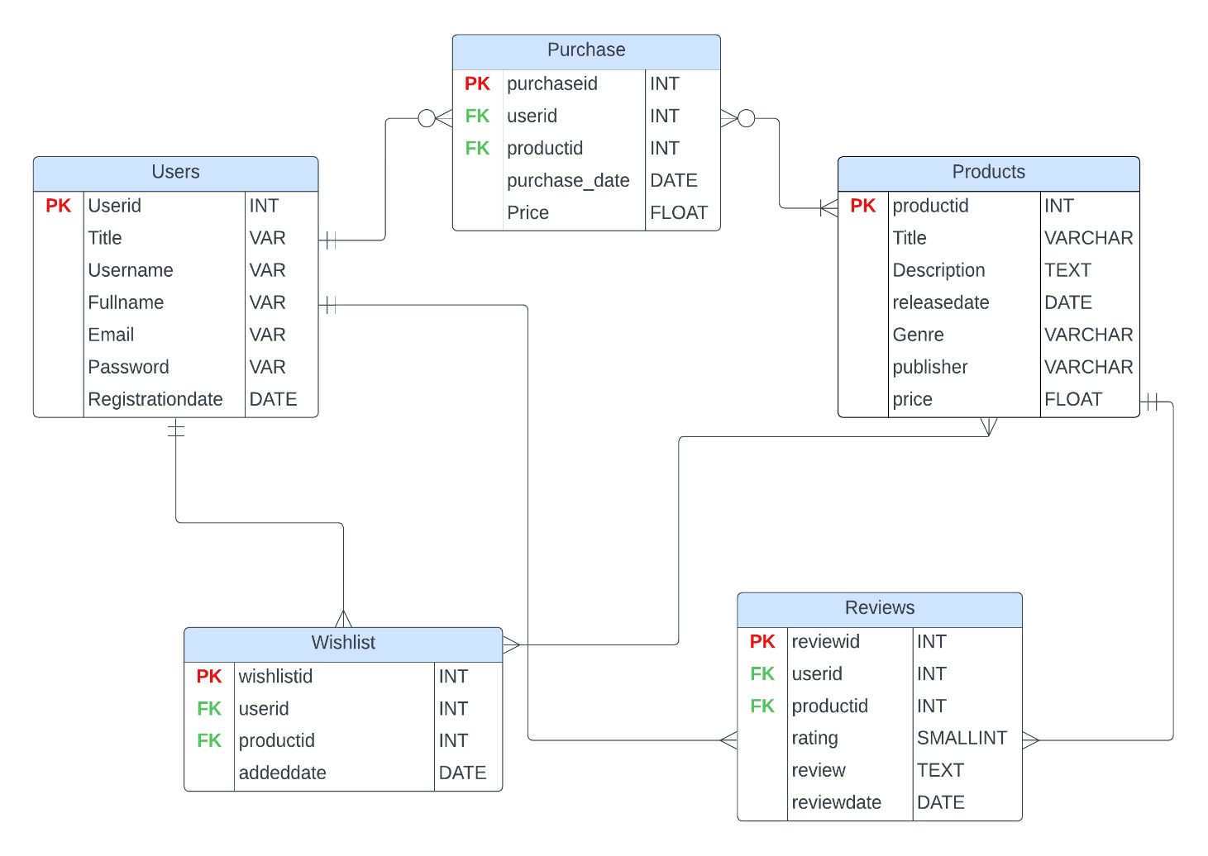

**Relationships:**

In the provided schema for a gaming company's database, several relationships exist between the tables to establish data integrity and support various functionalities. Here are the key relationships:

* **Users to Purchases (One-to-Many):** The Users table is linked to the Purchases table through the UserID column. This one-to-many relationship indicates that one User can make multiple purchases over time.
* **Products to Purchases (Many-to-Many):** The Products table is connected to the Purchases table through the ProductID column. This many-to-many relationship indicates that multiple games can be purchased by different users multiple times. Multiple users can buy the same game, and a single purchase can include multiple games if a user buys more than one game in a single transaction.
* **Users to WishList (One-to-Many):** The User table is linked to the WishList table through the UserID column. This one-to-many relationship allows customers to have multiple games in their wish lists.
* **Products to WishList (Many-to-Many**): Multiple games/movies can be added to multiple wish lists, showing that a product can be desired by different customers, and each wish list can include multiple products. The ProductID column in the WishList table directly associates specific games with individual wish lists.
* **Users to Reviews (One-to-Many):** The User table is linked to the Reviews table through the UserID column. This one-to-many relationship means that one customer can write multiple reviews.
* **Products to Reviews (One-to-Many):** The Products table is linked to the Reviews table through the ProductID column. This one-to-many relationship indicates that one game/movie can have multiple customer reviews.

**Conclusion**

In conclusion, the case study of the PlayStation Store highlights the significance of effective database design, as exemplified by the Entity-Relationship (ER) diagram and the relationships between its tables. The ER diagram serves as a fundamental blueprint, illustrating the complex connections between these entity relationships, whether one-to-many or many-to-many, underpin the store's functionality, enabling users to browse, purchase, and review games seamlessly. As gaming community grows and expands the platform will adapt new changes according to the consumer need for smooth process, providing a central hub for gaming communities digital distribution.

**Thank you!**

Done by: **Shahlob Shajahan**

**Cohort Dailan**